 ICD

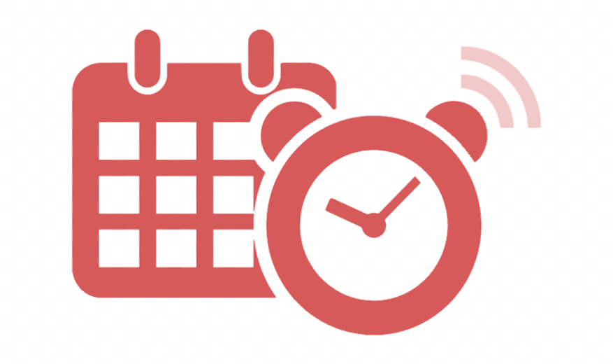

User Guide

CMSC 495 6380

September 19, 2019

Group 4

Dillon Cobb

Melissa Eardley

Maria Tkacheva

Allan Yu

# Revision History Table

|  |  |  |  |
| --- | --- | --- | --- |
| Date | Changed By | Change(s) | Version |
| 10/7/2019 | Dillan Cobb  Melissa Eardley  Allan Yu | Initial Revision | 1.0 |
| 10/11/2019 | Dillan Cobb | User Guide | 1.1 |
| 10/11/2019 | Dillan Cobb | Change Reminder | 1.2 |
| 10/11/2019 | Melissa Eardley | Updated Design | 1.3 |
| 10/11/2019 | Dillan Cobb | Added View Past Reminders | 1.4 |
|  |  |  |  |
|  |  |  |  |
|  |  |  |  |
|  |  |  |  |
|  |  |  |  |
|  |  |  |  |
|  |  |  |  |
|  |  |  |  |
|  |  |  |  |
|  |  |  |  |
|  |  |  |  |
|  |  |  |  |

**Overview**

In this instruction we are going to go over the complete functionality and usage of the Reminder Application. This instruction will be broken down into various sections that will associate with what functionality can be done with the Reminder Application.

**Minimum Hardware and Software Requirements**

* Electronic device (smart phone, computer, etc.)
* Internet Connection
* Web Browser

**Accessing the Application**

1. From the device, open the internet browser. (Figure 1)

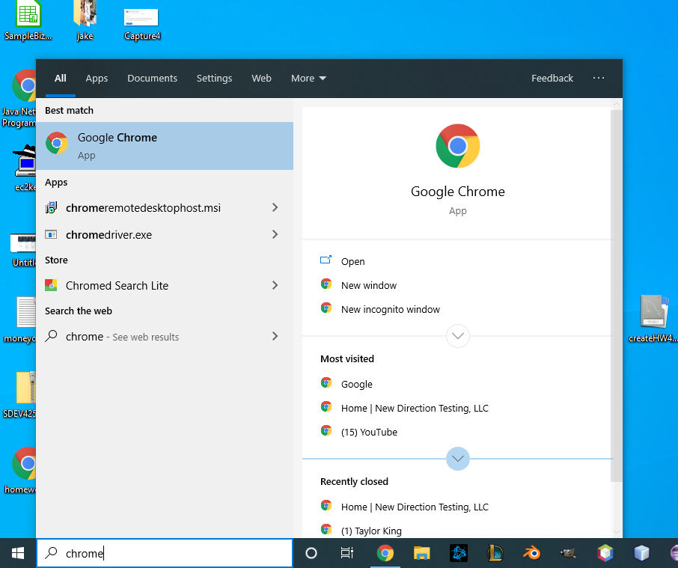  
Figure 1: Locating a web browser, and running it.

1. Inside of the browser, enter in the following url into the browser’s URL bar: <https://group-4-cmsc495-capstone.github.io/> (figure 2)

  
Figure 2: Navigating to the web address of the application.

**Creating an Account**

1. From the home screen of the web application, click ‘Register’ (Figure 3)
2. Click on each text field and input information into the text field (Username, Password, Email). (Figure 4)
3. Once complete, move to the ‘Register’ button, and click the button. (Figure )

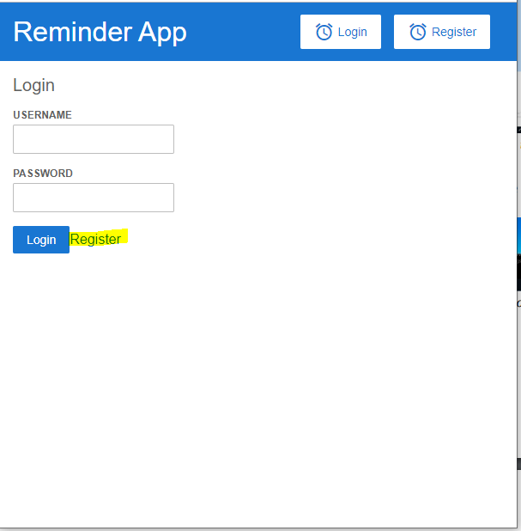  
Figure 3: Locating the account registration button.

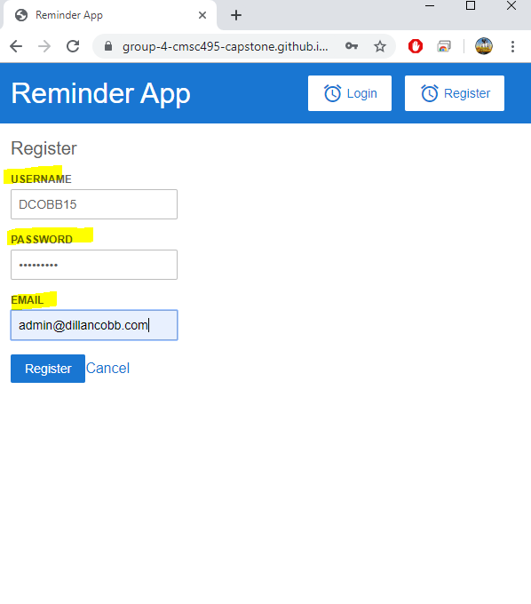  
Figure 4: Inputting account registration information.

1. Upon successful registration, the web browser will return to the home page and display “Registration Successful” message. (Figure 5)

**Logging into the Application**

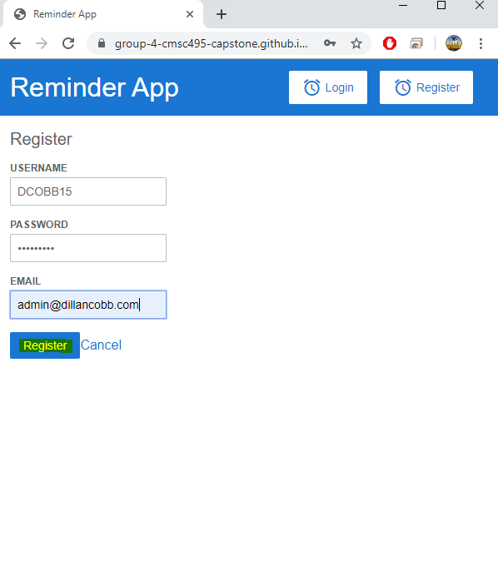  
Figure 5: Clicking the 'Register' button.

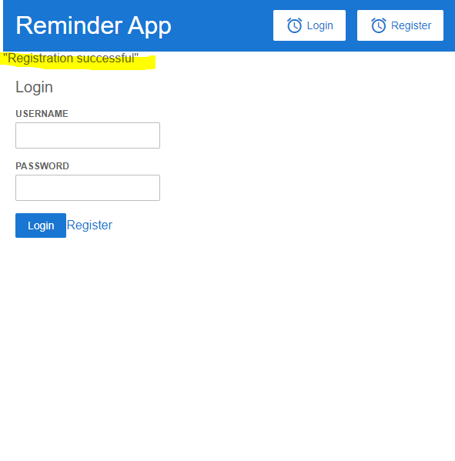  
Figure 6: System displaying "Registration successful" message. Signifying successful creation of an account.

1. From the application home screen, input account information into the ‘Username’ and ‘Password’ field.

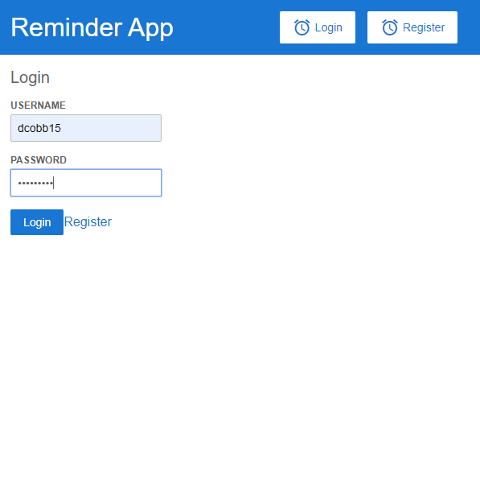  
Figure 7: Logging into the application.

1. Press the ‘Login’ button. (Figure 7)

**Creating a Reminder**

1. From the login screen, navigate to the ‘Add Reminder’ button and click it.
2. Input information into the various text fields ‘Name’, ‘Description’, ‘Date’, and ‘Time’. (Figure 8)

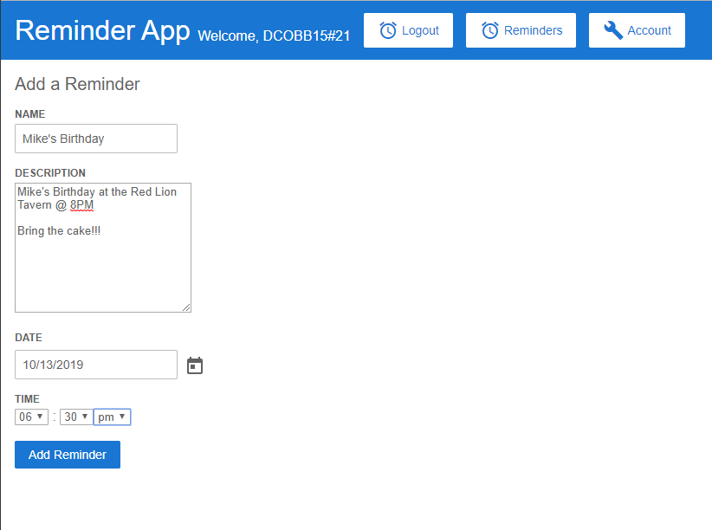  
Figure 8: Creating a reminder for "Mike's Birthday".

* Name – The name of the reminder. Ex: “Mike’s Birthday”
* Description – Detailed description of what should be reminded about. Ex: “Mike’s Birthday at the Red Lion Tavern. 8PM. Bring the cake!”
* Date – Date of reminder notification. Ex: 10/13/2019. This can be selected by clicking the small ‘Calendar’ icon, then selecting a date.
* Time – Time of the reminder notification. Ex: 6:30 PM

1. Once the Reminder has been filled out, navigate to the bottom to the ‘Add Reminder’ button is, and click it.

**Viewing a Reminder**

1. From the logged in page, locate the ‘Reminders’ button and click it. (Figure 9)

Figure 9: Viewing the reminders.

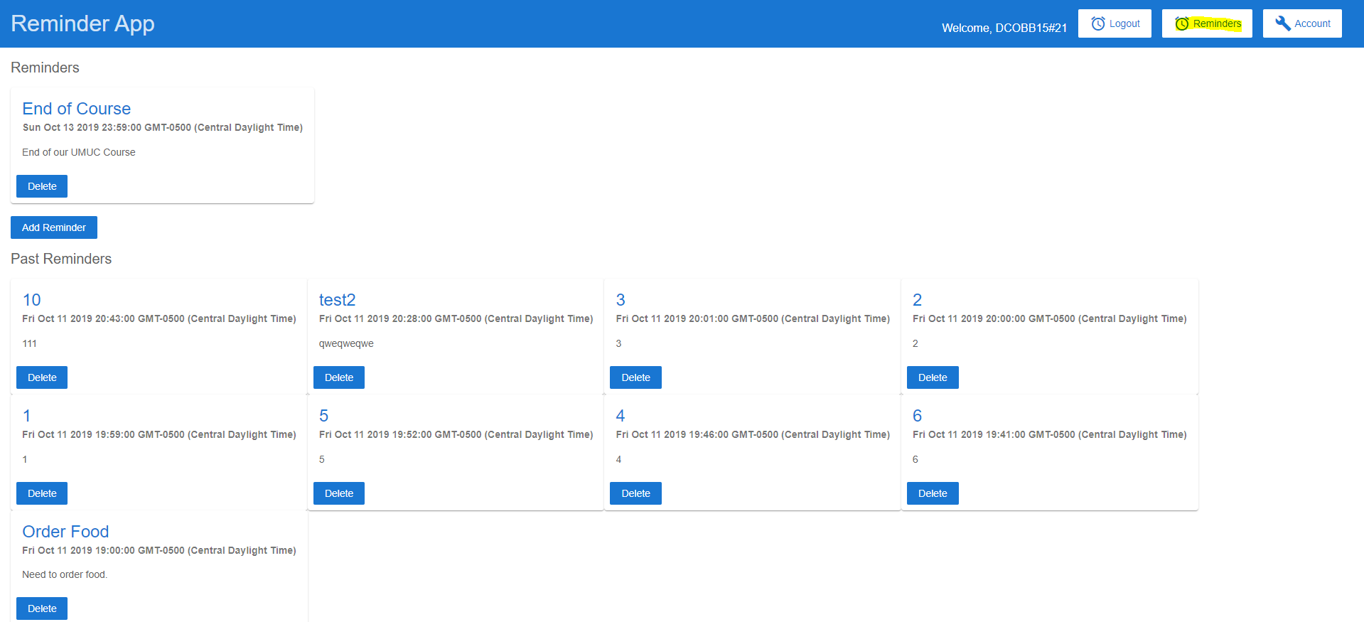  
Figure 9: Viewing the reminders.

**Editing a Reminders**

1. From the logged in page, locate the reminder to be edited.
2. Click the title of the reminder. (Figure 10)

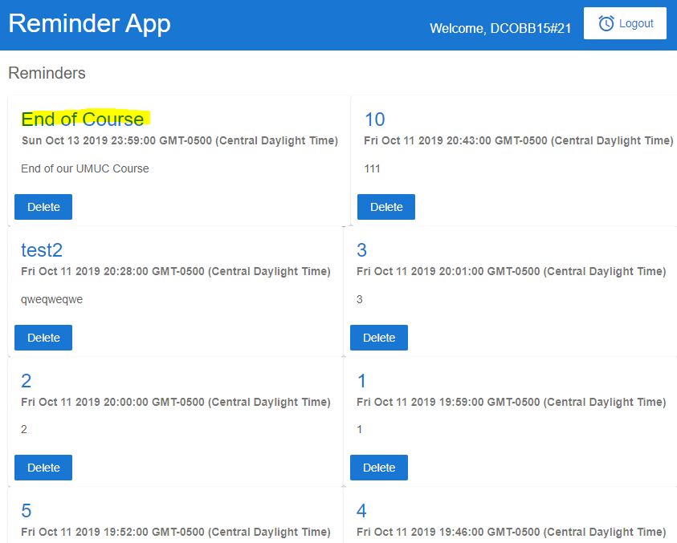  
Figure 10: Editing a Reminder by clicking on the title.

1. Update information, then locate the ‘Add Reminder’ button and click it. (Figure 11)

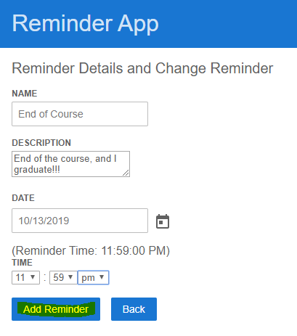  
Figure 11: Updating the reminder.

**Deleting a Reminder**

1. From the Reminders page, locate the reminder that is to be deleted.
2. Click the ‘Delete’ button that corresponds with the reminder. (Figure 12)

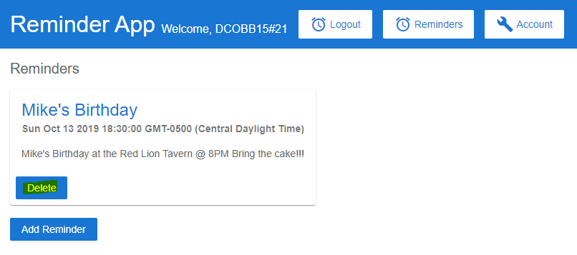  
Figure 12: Deleting "Mike's Birthday" reminder.

**Editing Account**

1. From the logged in page, click the top right button ‘Account’. A small menu bar will appear.

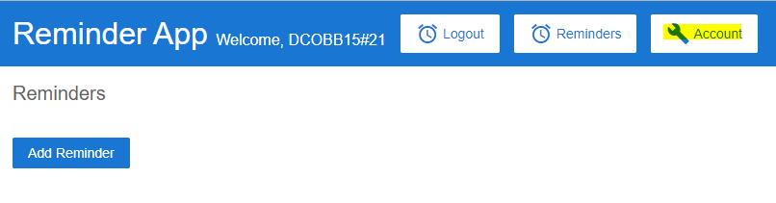  
Figure 13: Displaying the 'Account' button.

1. From the menu bar, click the ‘Settings’ option. (Figure 14)

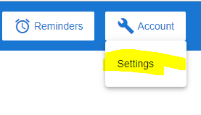  
Figure 14: Account - Settings drop down item.

1. Input either an email, or password to change that account detail.
2. Once satisfied, click the change button. (Figure 15)

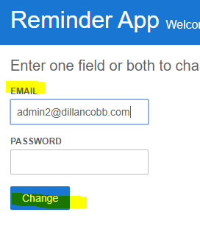  
Figure 15: Changing the e-mail address associated with the account.

**Logging Out**

1. From the logged in page, locate the ‘Logout’ button and click it. (Figure 16)

  
Figure 16: Displaying the 'Logout' button.